**CTF Challenge: Using CMD Command Terminal**

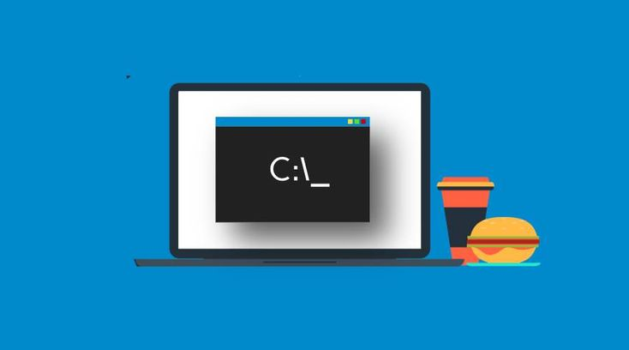

**1. Introduction**

This challenge will introduce you to basic CMD (Command Prompt) commands to help you get familiar with navigating and managing files and directories on your computer. These skills are essential for anyone pursuing a career in IT.



**2. Tools and Requirements**

A computer running Windows

Access to Command Prompt (CMD)

**3. Scenario**

You are an IT student learning how to use CMD. Your task is to perform basic file and directory operations using CMD commands.



**4. Process to Follow While Performing CTF**

**Step 1:** Open Command Prompt

Open the Command Prompt by pressing **Windows Key + R,** typing cmd, and pressing Enter.

**Step 2:** Basic Navigation

Use the following commands to navigate through directories:

**dir:** Lists the files and directories in the current directory.

**cd [change directory]:** Changes the current directory to the specified one. For example, cd Documents.

**Step 3:** File and Directory Operations

Use the following commands to create a directory.

**mkdir [directory]:** Creates a new directory. For example, mkdir new_folder.

**Step 4:** Solve the CTF

**5. Let’s Begin the Challenge**

**Questions**

Flag 1: Create a new directory named test_directory. What command did you use?

Answer: mkdir test_directory

Flag Captured

Flag 2: Change to the test_directory you just created. What command did you use?

Answer: cd test_directory

Flag Captured

**Hint:**

